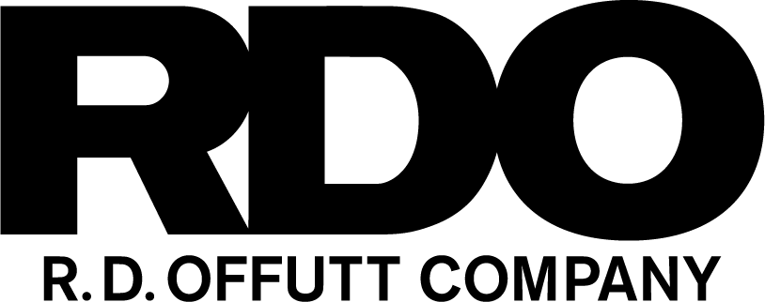
2023 RDO Caters Taters for Charity Application
Thanks for your interest in our annual fundraising event!
We are proud to partner with and support the work of many charitable organizations throughout the Fargo-Moorhead area. Our event is focused on raising dollars for programs and organizations that make our community a better place to live and work.
This application is meant to provide an understanding of who you are, the services and area of focus you provide, and how we might best partner during our luncheon event.
Guidelines for Applicants
Areas of Focus: RDO Caters Taters seeks to create positive impact on our community while supporting organizations that align with RDO’s values

- People in crisis
- People seeking to improve or advance their lives and the lives of others
- Veterans and First Responders
- Community enhancement
- Children, young adults, and the elderly with needs for support services

Causes and organizations that fall outside the scope of RDO Caters Taters:
- Those not serving Fargo/Moorhead
- Those primarily focused on the arts
- Those primarily focused on animal rescue / animal welfare
- Those focused on benefiting political parties, campaigns, and candidates
- Those primarily focused on religious programming
- Those focused on a singular school facility, district, or sports team
- Those focused on a singular club / youth sports team

Please answer the questions on Page 3 on a separate document and return by March 10, 2023 to Drew Sandberg at dsandberg@rdoffutt.com (or to 225 N Broadway, ND 58102, attn. Drew Sandberg). The selected charity will be notified in late May.

If you have any questions, please contact:
Drew Sandberg
R.D. Offutt Company
701-526-9324
dsandberg@rdoffutt.com
RDO Caters Taters for Charity 2023 Application Questions
Please answer these questions in a separate document and return by March 10, 2023 to
dsandberg@rdoffutt.com (or to 225 N Broadway, ND 58102, attn. Drew Sandberg). Selected charity will be notified in May.
- Charity Name:
- Contact Information:
- What is your mission?
- What is your greatest need?
- How would dollars raised from RDO Caters Taters be utilized?
- What support can your organization offer for this year’s event? This includes communication efforts to your supporters, volunteers/staff at the event, and more?
- What fundraising events are currently held for your organization and who are the hosts?
- When are your current fundraising events held?
- Did you have any significant fundraising efforts or events in 2022?
- How are donated funds allocated at your organization? What percentage stays local?
- What other sources of funding do you currently utilize?
- What percentage of donated funds is used for administrative fees?
- What other information would you like to share about your organization?
- Why should your organization be selected as an RDO Caters Taters charity of choice?
- Has your organization ever applied for a raffle permit?
- Please provide any volunteer opportunities for your organization.

Along with your responses to the application, please include the following information:
- Proof of nonprofit, 501(c)(3) tax-exempt status
- Pieces of marketing collateral that help share more information about programming and services
- Most recent annual report and 2023 budget
- List of Board of Directors

